NEXUS ENDURANCE WAHOO STAND

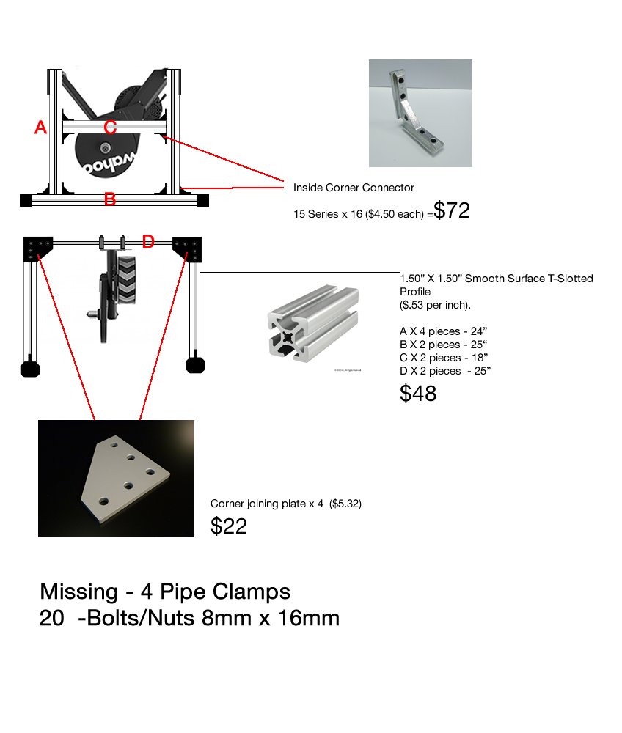
INSIDE CORNER CONNECTOR
CORNER JOINING PLATE

T SLOTTED PROFILE

